About me

My name is Nora. I am a mushroom farmer based in Vienna. I am a convinced environmental protector who believes that urban mushroom farming can make a change. I think if I can lower meat consumption by producing and selling Oyster Mushrooms then I did something for a better future.

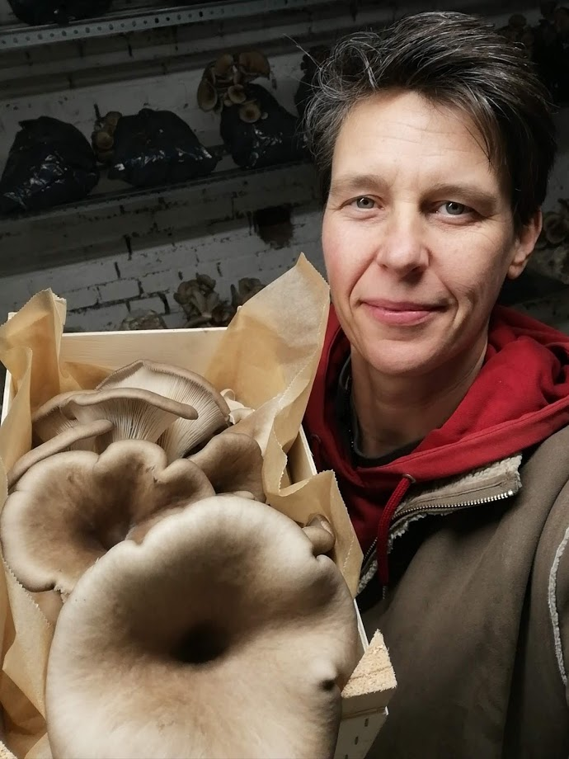

About the mushroom

Mushrooms are full of protein, fiber and many vitamins that makes them a perfect meat replacement and also can taste and feel like meat but has the benefits of a very low carbon footprint. Apart from this there are 6 surprising health benefit points from the Treehugger website:

**1. They have cancer-fighting properties.** A [study published in the journal Experimental Biology and Medicine](http://ebm.sagepub.com/content/235/11/1306.abstract) tested five types of mushrooms (maitake, crimini, portabella, oyster and white button) and found that they "significantly suppressed" breast cancer cell growth and reproduction, suggesting "both common and specialty mushrooms may be chemoprotective against breast cancer."

**2. Mushrooms are immunity-boosters.** We now know that lentinan can boost your immune system, but it has a helper, too. Beta-glucan is a sugar found in the cells walls of fungi (among other plants) that also helps boost your immune system. Lentinan comes from shiitake mushrooms, but beta-glucan is found in many varieties, namely the common button mushrooms.

**3. They help lower cholesterol.** In general, mushrooms are cholesterol free, but they're also a good source of chitin and beta-glucan, which are fibers that lower cholesterol. A [study in the International Journal of Medicinal Mushrooms](http://www.dl.begellhouse.com/journals/708ae68d64b17c52,6ea99e900554f74c,22589d00082034bf.html) in the International Journal of Medicinal Mushrooms found that pink oyster mushrooms reduced total cholesterol and LDL ("bad" cholesterol) in hypercholesterolemic rats.

**4. They're high in B and D vitamins.** Mushrooms are one of the few food sources for vitamin D, a fat-soluble vitamin that our bodies can make with exposure to sunlight and vitamin B12, which is key for vegetarians as it's most often found in animal products.

**5. Mushrooms have anti-inflammatory powers.** Mushrooms contain a powerful antioxidant called ergothioneine, which helps lower inflammation throughout the body. Multiple [studies](https://misuse.ncbi.nlm.nih.gov/error/abuse.shtml) have shown that reishi mushrooms have multiple health benefits: They fight disease, lower inflammation, suppress allergic responses, reduce tumor growth and more.

**6. They could help fight aging.** In a study at Penn State, researchers found that mushrooms have high amounts of two antioxidants, ergothioneine and glutathione, which are both associated with anti-aging properties. "What we found is that, without a doubt, mushrooms are [the] highest dietary source of these two antioxidants taken together, and that some types are really packed with both of them," said Robert Beelman, professor emeritus of food science and director of the Penn State Center for Plant and Mushroom Products for Health, in [a statement](http://news.psu.edu/story/491477/2017/11/09/research/mushrooms-are-full-antioxidants-may-have-antiaging-potential). The amounts of the antioxidants vary by species; the winner "by far" was the wild porcini mushroom, researchers said.

Similarly, a [2019 study](https://content.iospress.com/articles/journal-of-alzheimers-disease/jad180959) found that seniors who ate more than 300 grams of cooked mushrooms a week were half as likely to have mild cognitive impairment. The six-year study — conducted from 2011 to 2017 — collected data from more than 600 seniors over the age of 60 living in Singapore. The researchers looked at ergothioneine as the possible reason for this impact.